Adding Project to Github

# Step 1

Download the Project from Moodle

# Step 2

In the folder you downloaded the project, right click and open gitbash here

# Step 3

Now run the following commands on the gitbash

git init

git add . //: add everything to the route of github

git status //: show you what you have added

git commit -m 'first commit'

git remote add origin <git url>

git push origin master

If you run into errors with ssh keys follow the links and create the ssh and add this to the agent

<https://help.github.com/articles/generating-a-new-ssh-key-and-adding-it-to-the-ssh-agent/>

<https://help.github.com/articles/checking-for-existing-ssh-keys/>

<https://help.github.com/articles/adding-a-new-ssh-key-to-your-github-account/>

Collaborating with others

# Step 1

Split into groups of 2. Choose whose project will be the ‘master’ branch

# Step 2

The person whose project was chosen should go to settings on their repo. They should then add their partner as a collaborator.

# Step 3

The collaborator should ‘git clone’ the project onto their own machine. They should then make some changes, commit their work, and push.

# Step 4

Both team members should pull from the repo every time they wish to make changes, to ensure they have the most up to date code, then change commit and push. The aim is to create 1 full webpage including the following:

* Nav bar
* Jumbotron
* Responsive grid
* Footer

Split each item between the team, so that you are each working on different items on the same page.

# Note

If you get a merge error (where 2 people edit the same line) you just need to tell github what code is correct. (<https://www.youtube.com/watch?v=IcxW145oWAU>)

# Step 5

When complete, deploy to cloud 9 (below) and post your link to the forum. **Each team member should post a link!**

# Step 5

* Add workspace name
* Paste in your link from github into the clone from git repository
* Then hit create workspace and this will clone your git repository into the workspace

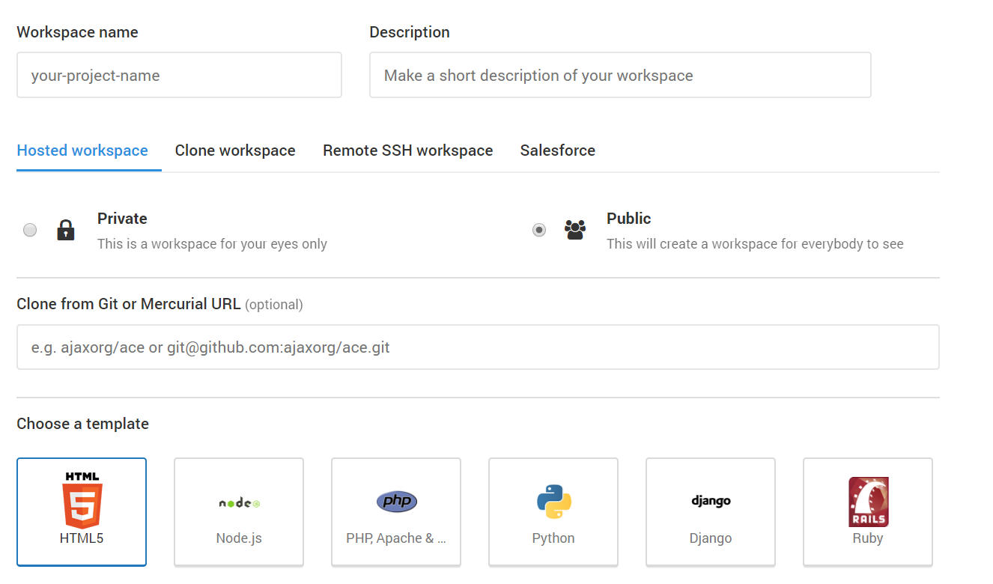

Adding New Pages to call from a JSON file using JavaScript

# Step 1

Create the following files in your cloud 9 respository:

* index.html
* data.json
* script.js

# Step 2

Add the following code to your html file

<html>

<head><title>How to Load Content from Text File using AJAX</title></head>

<body>

<h1>How to Load Content from JSON File using AJAX</h1>

<div id='update'>This is a div. This will be updated with Contents from xml file by AJAX.</div>

<script src="script.js"></script>

</body>

</html>

# Step 2

Add the following code to your JSON file

[

{

"name" : "George",

"gender" : "male",

"color" : "white-mustard",

"age" : "5 years"

},

{

"name" : "Pety",

"gender" : "female",

"color" : "white-black-mustard",

"age" : "3 years"

},

{

"name" : "Alex",

"gender" : "male",

"color" : "white-grey-black",

"age" : "3 years"

},

{

"name" : "Rex",

"gender" : "male",

"color" : "white-mustard",

"age" : "2 years"

}

]

# Step 3

In the Javascript file, add the AJAX call to parse through the JSON file to print out information.

Look at the AJAX slides for reference